Regular Faculty Overload
Contract Submitter Instructions

A Custom Bolt-on PeopleSoft Application
Table of Contents

Regular Faculty Overload Contract Search Page “Find An Existing Value” Tab 3
Regular Faculty Overload Contract Search Page “Add A New Value” Tab 6
Regular Faculty Overload Contract Submission Page 7
HR Instructions 10

Regular Faculty Overload Process Search and Entry

Regular Faculty Overload Entry Search Page “Find an Existing Value” Tab

- Navigate to SU Custom > Employment Contract Processing > Reg Faculty Overload Contracts > Reg Faculty Overload Contracts.

  - Use this search page to search for faculty that already have a GullNet overload record (contract) started.
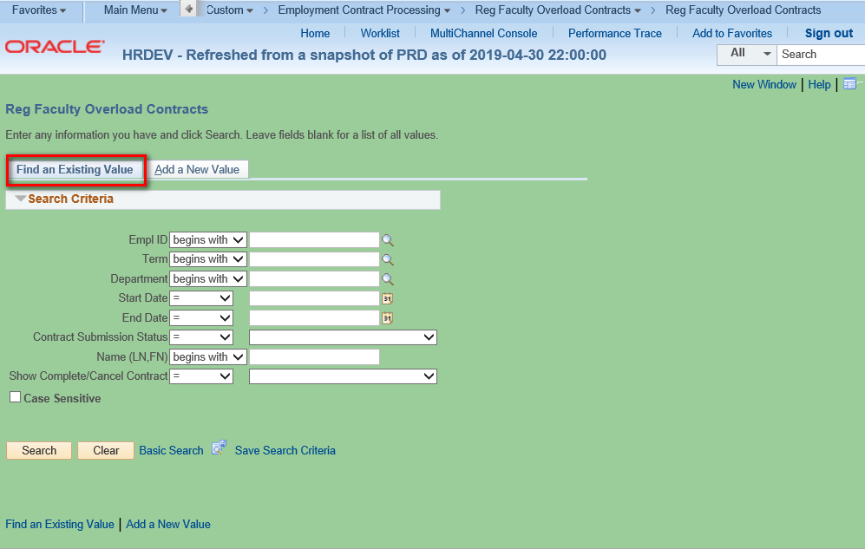

  - You can search by Empl ID, Term, Department, Dates of the Contract, Name and Contract Type and/or any combination thereof. Also, you can use this to search the list by contract submission status. The submission statuses (in normal processing order) are as follows: Not Submitted; Chair Approval Needed; Faculty Signoff Needed; Chair Signoff Needed; Dean Signoff Needed; HR Data Input Needed; Commitment Acct Input Needed; Completed; or Cancelled. Below is what you would choose to search for all faculty who need the Dean’s Signoff.
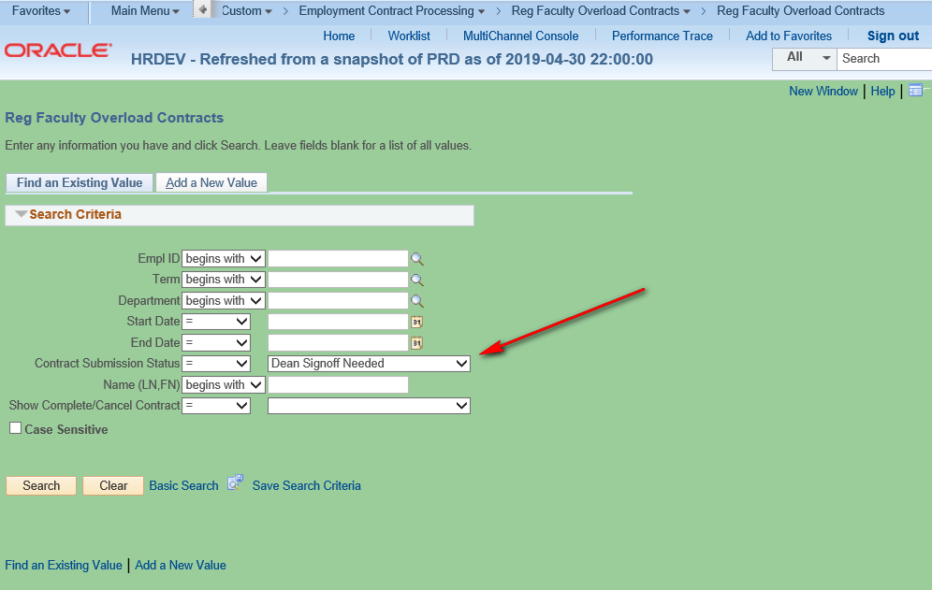

  - Also, you can search for all Completed or Cancelled Contracts by selecting as in the example below. Alternatively, choose “Contracts Waiting Action” for all contracts in process.
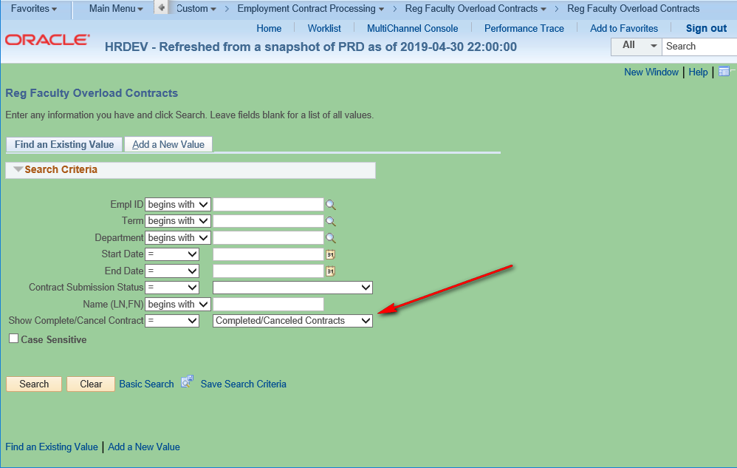

Regular Faculty Overload Contract Entry Search Page “Add A New Value” Tab
Click on the “Add a New Value” tab to select an regular currently employed faculty member so you can proceed to enter a new contract.
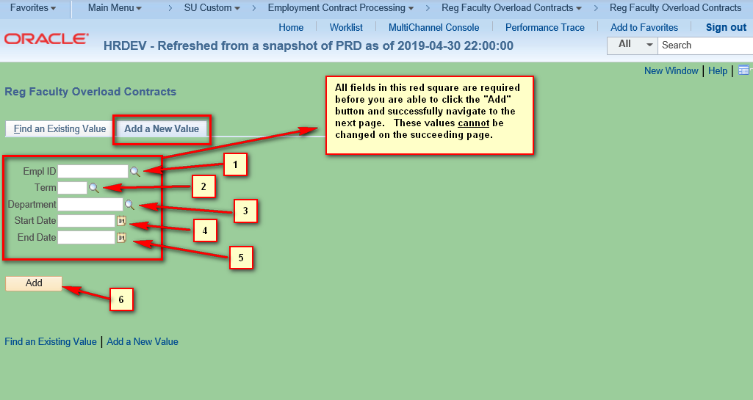

- The page shown above contains numbered field and controls (numbered for reference purposes for this document only as they do not appear on the page). They are:
  - Empl ID: If you know the emplid of the employee you can enter it here or click on the magnifying glass to see a list of eligible faculty. Clicking on the magnifying glass will allow you to search for the faculty member by name.
  - Term: This is the term in which the faculty member will teach.
**Henson School Specific Guidelines**
If a faculty member’s Fall overload contract could not be executed in the Fall semester because of either uncertainty with the Spring workload or because of an unforeseen change in circumstances, we will treat the overload as being related to a full academic year. In other words, the overload pay will be the sum of the overload in the Fall and the Spring (this is normal), but it will be Spring courses only that push them over the 24 contact hour maximum. In the Notes section of the contract, you will want to write that this overload represents the total for the academic year.
  - Department: Enter the department code you wish to use to fund the position. If you do not see the code you wish to use, please contact HR so they can set it up.
  - Start Date: Start date of the contract.
  - End Date: End date of the contract.
  - Clicking the yellow “Add” button in the screenshot above will take you to the Regular Faculty Overload Contract Submission page

Regular Faculty Overload Contract Submission Page

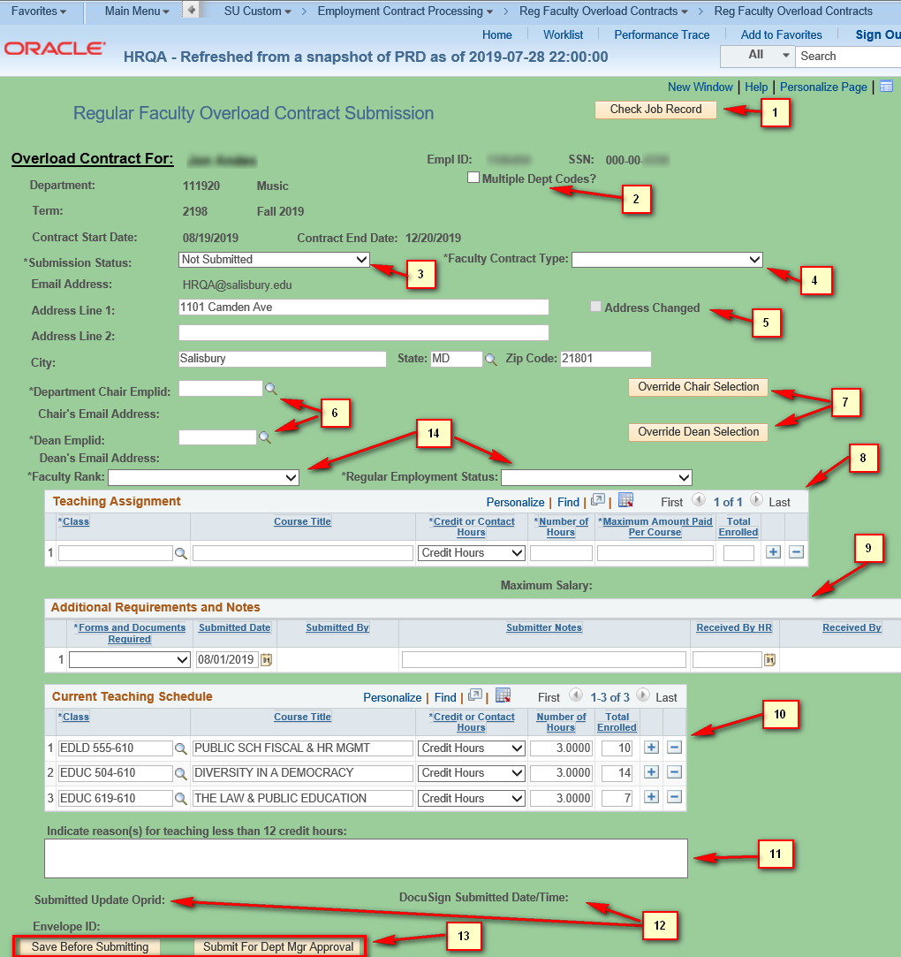

- The page shown above contains numbered field and controls (numbered for reference purposes for this document only as they do not appear on the page). They are:

  - The “Check Job Record” button allows you to see the job records of the employee. They are based on the Empl Record of the employee and include active as well as non-active jobs. This is for informational purposes only.

  - Multiple Dept Codes?: Only check this when you will be allocating the contract salary among more than one department code. It opens a small data entry window where you must enter at least two department codes. The pecentages must add up to 100. Contact HR if you do not see your department codes when you select the department magnifying glass.
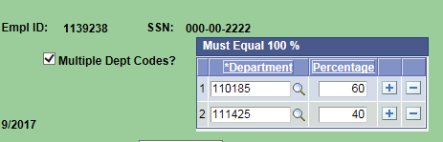

  - Submission Status: This is a read-only field and is set to “Not Submitted” until the contract has been submitted.
  - Faculty Contract Type: You have two selections for this required field, Overload Faculty and Part-Time Faculty.
  - Address Changed: This checkbox is not editable and only is checked if you change any address information. When the page is loaded the home address of the Faculty member is loaded. If you modify any of the fields (Address Line 1 or 2, City, State, or Postal Code) this box will be checked when the address is changed. This will alert the HR Office to send the Faculty the proper paperwork needed to formally change the home address.
  - Department Chair Emplid and Academic Dean Emplid: These required fields will normally only have one value selectable from the search magnifying glass. These values are tied to the Department in which the faculty will be teaching. When selected, the email addresses below each emplid will automatically be populated. If there are no values when you click the magnifying glass contact HR.
  - The Override buttons allow you to change the values displayed in the fields from #6 above. For example, clicking the Override Chair Selection button will allow you to see a list of all current employees when you click on the Department Chair Emplid field lookup (i.e. magnifying glass).
  - Teaching Assignment: At least one course must be entered in order for the record to be saved. The courses available via the lookup are based on courses that are currently in the schedule in GullNet for the selected term. The only field not required for the Spring or Fall semesters is “Total Enrolled” which is only required for the Winter/Summer semesters. You will notice that a read-only field called Maximum Salary which appears beneath the table totals the salaries in the table above.
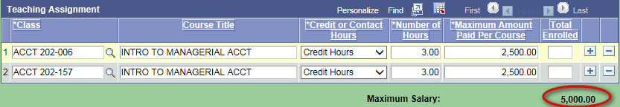

  - Additional Requirements and Notes: These are additional documents required or notes that you can enter that the Faculty will have to provide based on their job information (contact HR for further clarification). Please leave as “None” if no additional documents are required or if you have no notes to make.
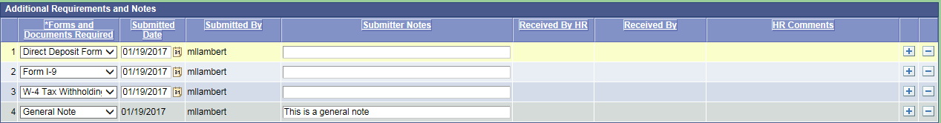

  - This is the current teaching load for the faculty member. This is loaded from GullNet when you first go to this page. It is not refreshed after you save the page. You may edit any fields in this grid as well as delete courses or add other courses. Important: In certain situations course/lab combinations will not accurately reflect the true credits/load assigned. It is imperitive that the submitter double check the credits on the faculty schedule and make a correction to the "Number of Hours" field, if necessary.
  - Please use this for any notes related to load that may be important. NOTE: This will appear on the DocuSign contract.
  - Submitted Oprid and Submitted Date: These read only fields are populated when you submit the contract.
  - The “Save Before Submitting” button can be pressed to save all your data without submitting the contract process through DocuSign. The “Submit For Dept Mgr Approval” button actually starts the DocuSign workflow process.
  - This is the rank of the instructor (i.e. Assistant Professor, Associate Professor) and the employment status (i.e. Full-Time Tenured, Full-Time Tenure Track). Both are required fields.

HR Instructions

When the contract “Submission Status:” is “HR Data Input Needed” it is ready for HR submission. The section below is only visible to HR staff.

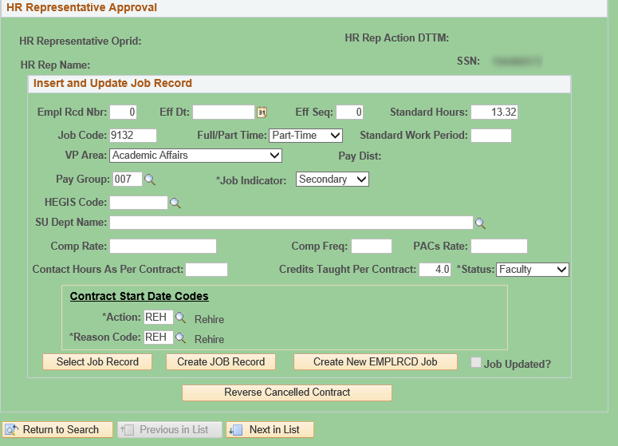

- The page shown above contains fields which will be used to populate the Job record of the employee when the HR submitter clicks on the “Create JOB Record” button or the “Create New EMPLRCD Job” button.
- Fields shown on this page containing values will be populated from data entered by the contract administrator who started the contract process as well as programmed default values. HR may still edit these though if they wish.
- When the HR submitter clicks on the “Select Job Record” they will see a list of all the highest job rows for each EMPL_RCD for that employee. Clicking the select button at the end of the row will populate the data for other fields. These fields are also editable if you wish to use your own values.
- Once the the HR submitter clicks on the “Create JOB Record” or “Create New EMPLRCD Job” button the appropriate the “Job Updated?” check box will become checked and the submission status will be updated to “Commitment Acct Input Needed”, but if there is an error please contact IT
- Finally, if a contract is cancelled HR can click on the “Reverse Cancelled Contract” button to set the contract status back to “Not Submitted”. This will allow the Admin to edit the contract and resubmit. This will also create a new envelope in Docusign.

Updated 9/26/2019

