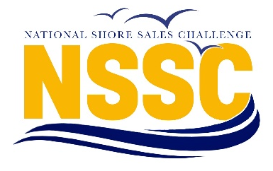

2024 Expense Reimbursement Request

LODGING: Hotel for 3 nights, up to 3 rooms for 1 Faculty Coach and 2 Student Competitors in the partnering hotels. Universities are reimbursed for either 3 rooms (if student competitors are of different genders and/or sex) OR 2 rooms (if student competitors are the same gender and/or sex). Lodging reimbursement offered to all universities that attend NSSC. Detailed hotel receipt is required.

TRANSPORTATION: Airfare for 1 Faculty Coach and 2 Student Competitors (economy round-trip at lowest airfare). Ground mileage is $0.67 per mile for personal vehicles. Documentation of mileage and route traveled is required. Your mileage reported MUST match the route YOU provide. Max of $1500 reimbursement per university for total travel expenses (air and/or ground). If total expenses are less than $1500 then that lesser amount will be reimbursed. Full airline itinerary is required. All receipts must show payment and purchasing transaction

NOTE: Only one reimbursement form per university. (If your students have paid on their own, they should seek reimbursement from your university/sales center. NSSC will do a combined reimbursement to the sales center.)
The W-9 will need to match the person/university that we are reimbursing, including the address.
Contact Name

Contact Phone

College or University
W-9 Address
Check Payable to
(MUST match name on W-9)
Check Mailing Address

HOTEL/LODGING EXPENSES:

Are Role Play student competitors of the same sex/gender? ( one) Yes ( Eligible for Max 2 rooms X 3 Nights)
No ( Eligible for Max 3 rooms X 3 Nights)

Date | Description | Amount
 | - Total Hotel Lodging Expenses =

TRAVEL EXPENSES (Air/Rental Car/Mileage, etc):
Date | Description | Amount
 | - Total Travel Expenses =

If B > $1500 Total Travel Expenses Reimbursed = $1500 ------------------------Write amount in row C
If B < $1500 Total Travel Expenses Reimbursed = B (Actual Cost) --------------Write amount in row C

- Total Travel Reimbursement Requested =

Grand Total Reimbursement Requested = A + C =

Signature: ______________________________________________________ Date: ____________________________
*REIMBURSEMENTS MUST BE RECEIVED BY (May 6, 2024) OTHERWISE, A 50% PENALTY WILL BE APPLIED.
**Reimbursement will not be made for any extras, including airline preferred seating fees, personal flight costs (ex/ drinks on plane), GPS, Collision Damage Waiver (CDW) or Loss Damage Waiver (LDW) car rental insurance coverage**

CHECKLIST (Please ):
- Is w-9 attached and complete?
- Are all receipts attached? (hotel/air receipt must show payment made)
- Is reimbursement form signed and dated?
- W9 Address and Name match the name of the entity for whom the check is made out to
- Only one reimbursement form is being submitted for the university.

