**Navigate** - Availability for Appointments

Salisbury University has launched the Navigate platform for faculty, staff, and advisors. Driven by data and campus connections, the goal of Navigate is to support students on their path to timely degree completion. Use this Quick Start Guide to make the most of your experience.

* Navigate is a Quick Link under Faculty & Staff on SU’s website
* Log into Navigate (through Chrome) using your university credentials
* Set up Availability for Appointment Scheduling: This allows you to communicate your available times to meet with students for Program Planning, office hours, undergraduate research, etc. You manage your availability from your home screen. See Appendix A for detailed instructions on setting up your availability.

GETTING STARTED

IMPORTANT NOTES:

* Program Planning appointment availability is no longer done in GullNet.
* You are able to set up availability for multiple types of appointments: Program Planning, office hours, research mentorship, etc.
* If your availability is set up in Navigate, students can sign up for an appointment through the Navigate student app.
* When students sign up for an appointment through Navigate, they are sent an email reminder the day before and a text message reminder 30 minutes before.

**Appendix A** – **Setting Up Availability**

Each semester, you need to set up availability in Navigate so that students can schedule appointments to see you – or know when you are available for walk-ins. Separate (but overlapping) times can be set up for Program Planning, office hours, research mentorship, etc. Note that locations and services can be updated upon request, so contact Melissa Boog, Heather Holmes, or Sarah Timko-Jodlbauer if you would like to see something added.

**Adding Program Planning Availability**

**Step 1:** Across the top navigation bar, make sure the term is set to the current academic term.



**Step 2:** Click on the third tab (My Availability) and choose Add Time in the Actions dropdown.

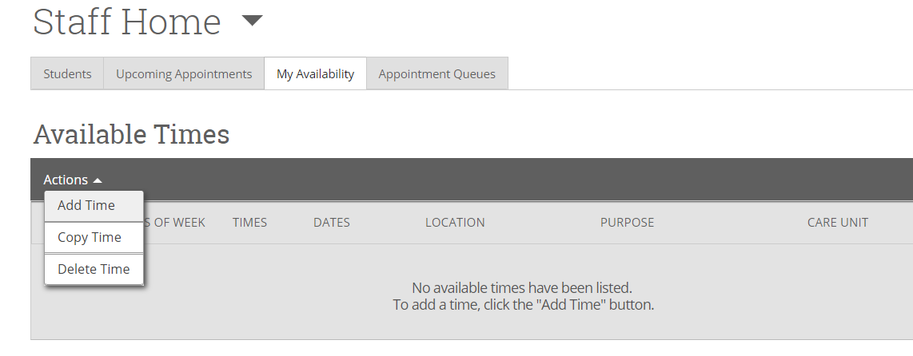

**Step 3:** Select the days and times when you are available to meet with students. (You don’t have to block off your teaching schedule; Navigate already knows that you aren’t available at those times.)

**Step 4:** Select A Range of Dates. Note: Check the [University Calendar](https://webapps.salisbury.edu/calendars/Program/all_calendars.asp) for Program Planning dates.

**Step 5:** Select the Personal Availability Link, if you wish to send students a link to directly access your availability.

**Step 6:** Click on “Appointments” and “Campaigns.” (More information about targeted campaigns to follow.) Note: For Program Planning, students must sign up for an appointment at least 24 hours in advance.

**Step 7:** Choose “In-Person”, “Virtual”, or both options under meeting type. If you select “In-Person” and “Virtual” students can choose the option when they schedule. You will see the appointment type on your Outlook calendar and on the email notification.

**Step 8:** Choose “Advising” under Care Unit.

**Step 9:** Choose “Faculty Advisor’s Office” under Location. Note: If you only have virtual availability the student will only be able to schedule a virtual meeting.

**Step 10:** Choose either 15-Minute Program Planning, 20-Minute Program Planning or 30-Minute Program Planning, depending on how long a typical appointment lasts for you. If you would like students to choose the amount of time they think they need, you can choose more than one option.

**Step 11:** Enter URL if you have selected virtual as a meeting option.

**Step 12:** Enter any special instructions you may want to share with your advisees (e.g. Office located in Henson Hall Room xxx; Please come prepared with a list of courses you plan to take in the fall; etc.)

**Step 13:** Leave Max Number of Students per Appointment set to 1.

**Step 14:** Click the Save button.

**Step 15:** It is essential that you remember what you coded for Steps 6 – 8 so you can tell students how to find your options in their Navigate app (see Appendix B).

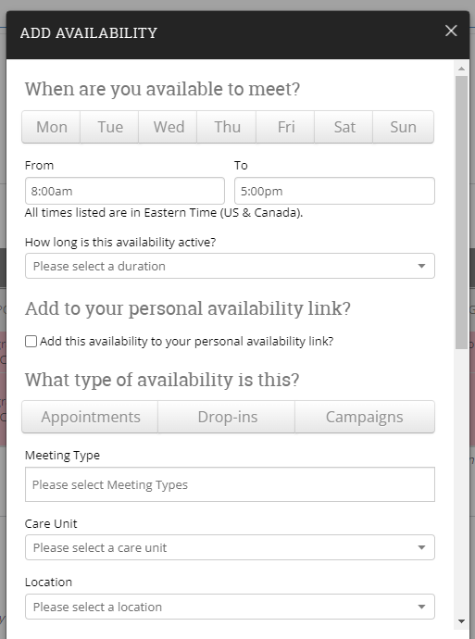

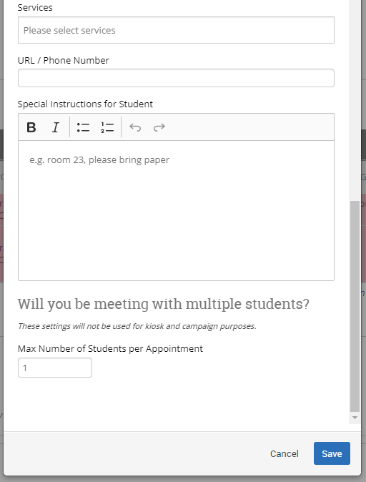

**Adding Office Hours Availability**

**Step 1:** Across the top navigation bar, make sure the term is set to the current academic term.

**Step 2:** Click on the third tab (My Availability) and choose Add Time in the Actions dropdown.

**Step 3:** Select the days and times when you plan to hold office hours.

**Step 4:** Select current academic term in the “How long is this availability active” dropdown.

**Step 5:** Click on “Appointments” if you are willing to have students make appointments during your office hours. Click “Drop-ins” if you prefer for students to drop in instead of signing up in advance. You may click both if you are ok with either.In addition, always click on “Campaigns” in case you decide to target students through a campaign (more information to follow).

**Step 6:** Choose “In-Person”, “Virtual”, or both options under meeting type. If you select both students can choose the option when they schedule. You will see the appointment type on your Outlook Calendar and on the email notification.

**Step 7:** Choose “Faculty Office Hours” under Care Unit.

**Step 8:** Choose “Faculty/Professor’s Office” under Location.

**Step 9:** Choose the appropriate service(s) you plan to provide to students during your office hours. You can list a specific timeframe or leave it open by simply choosing “Office Hours.”

**Step 11:** Enter URL if you have selected virtual as a meeting option.

**Step 12:** Enter any special instructions you may want to share with your students (e.g. Office located in Perdue Hall Room xxx; If you are bringing snacks, I prefer dark chocolate; etc.)

**Step 10:** Change the Max Number of Students per Appointment if you are willing to meet with more than one student at a time.

**Step 11:** Click the Save button.

**Step 12:** It is essential that you remember what you coded for Steps 6 – 8 so you can tell students how to find your options in their Navigate app (see Appendix B).

Other Available Times Options…

**Copy Time** - To copy a time, select the time you would like to copy and then click the Copy Time button. The availabilities will be copied and a dialog will open allowing you to make edits or to save your newly created availability. (If your original time had a range of dates, you will have to update them in the new version.)

**Delete Time-** To delete your time, simply select the time and click the Delete Time button.

**Note:** Inactive availabilities are highlighted in red in the Times Available grid. That simply means that we are outside of that time period. However, students can see the times you have set for the future and are able to set appointments for those times before they are active.

**Other Reasons to Set Availability?**

If you would like to set availability for reasons other than Program Planning and Office Hours, we may be able to add that functionality. Please contact Melissa Boog, Heather Holmes, or Sarah Timko-Jodlbauer with your request.

**Appendix B** – **Setting Up Appointments**

**There are two ways for students to set up an appointment with you:**

* **Campaign Access:** If you create a **campaign**, that invites students to set up a time with you by providing a specific link to set up an appointment.  If you choose this option, the parameters set in the campaign MUST match the parameters you set up under “My Availability.”

Campaign Directions found on the Navigate at SU webpage: <https://www.salisbury.edu/administration/academic-affairs/navigate-at-su.aspx>)

* **Appointment Access:** If you choose to simply email students and tell them to set up an **appointment** (rather than creating a campaign), they will go into their Navigate app and answer a series of questions regarding the particulars of the appointment:
  + Who they want to meet with – “Faculty Advisor/Mentor”
  + What type of appointment – “20-minute Program Planning”
  + Location – “Faculty Advisor’s Office”

It is REALLY important that the answers they give when setting up appointments match the details of your specific availability.  As such, it may be best for you to include that detailed language when emailing students:

“It’s time to think about your classes for the upcoming semester.  Please log into the Navigate app and schedule a 20-minute Program Planning appointment with me (your faculty advisor/mentor).  We will meet in my office (Faculty Advisor’s Office).  I look forward to seeing you then!”

Note: The underlined parts are those that will vary depending on how you set up your appointments.

If what students search for doesn’t match what you set up, they will receive the following message:

