Summer/Winter Faculty Contract
Contract Submitter Instructions

A Custom Bolt-on PeopleSoft Application
Table of Contents

Summer/Winter Faculty Contract Entry Search Page “Find An Existing Value” Tab 3
Summer/Winter Faculty Contract Entry Search Page “Add A New Value” Tab 6
Summer/Winter Faculty Contract Submission Page 8
HR Instructions 11

Summer/Winter Faculty Contract Search and Entry

Summer/Winter Faculty Contract Entry Search Page “Find an Existing Value” Tab

- Navigate to SU Custom > Employment Contract Processing > Summer/Winter Faculty Contract > Summer/Winter Faculty Contract.

  - Use this search page to search for summer/winter contracts that already have a GullNet record (contract) started, cancelled or completed.

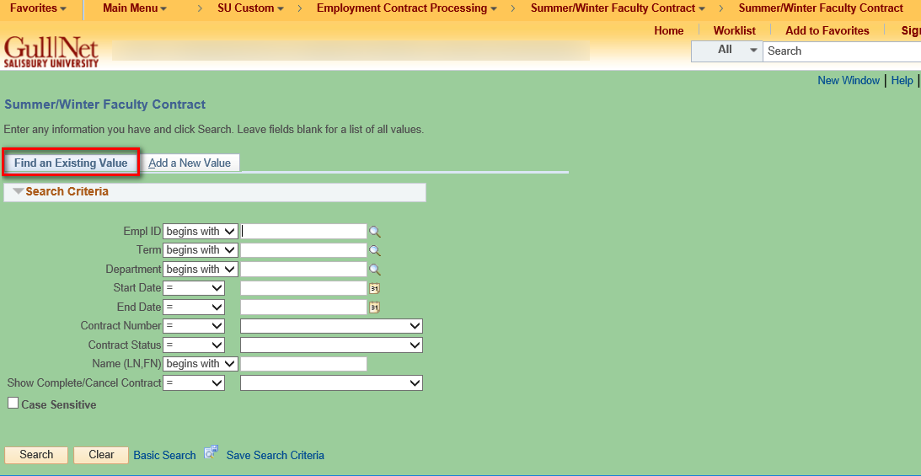

  - You can search by Empl ID, Term, Department, Dates of the Contract, Contract Status, Name and/or any combination thereof. Also, you can use this to search the list by Contract Status. The submission statuses (in normal processing order) are as follows: Not Submitted; Faculty Signoff Needed; Dean Signoff Needed, HR Signoff Needed; HR Data Input Needed; Commitment Acct Needed; Completed; or Cancelled. Below is what you would choose to search for all faculty who need the Dean’s signoff.

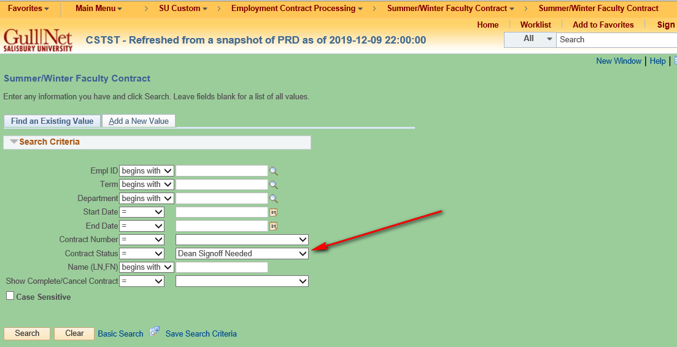

  - Also, you can search for all Completed or Cancelled Contracts by selecting as in the example below. Alternatively, choose “Contracts Waiting Action” for all contracts in process.

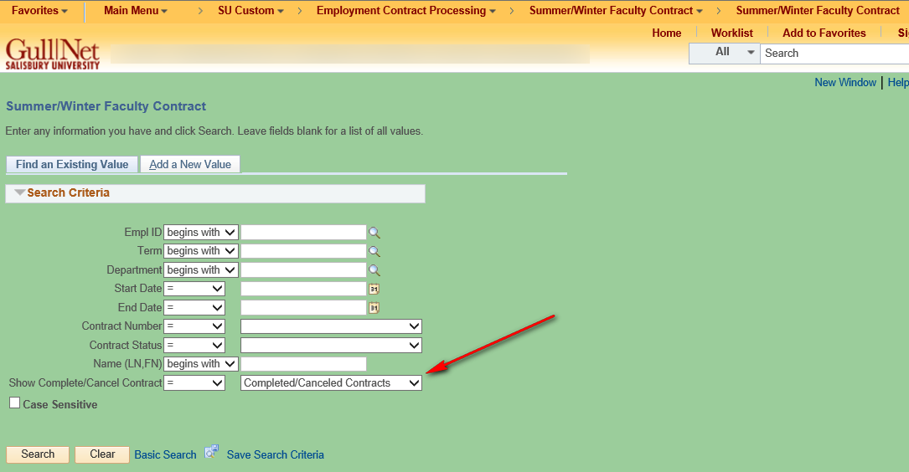

Summer/Winter Faculty Contract Search Page “Add A New Value” Tab
Note: This is where you select faculty who may be either adjunct or regular faculty and enter information in order to process their summer/winter contracts.

Click on the “Add a New Value” tab to select a faculty so you can proceed to enter a new contract.
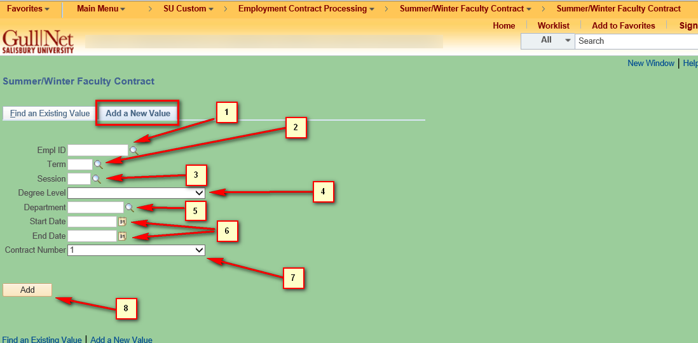

- The page shown above contains numbered field and controls (numbered for reference purposes for this document only as they do not appear on the page) needed to be completed in order to submit a Summer/Winter term contract. They are:
  - Empl ID: If you know the emplid of the faculty you can enter it here or click on the magnifying glass to see a list of adjunct and regular. Clicking on the magnifying glass will allow you to search for the faculty by name. NOTE: Be very cautious and make sure you have the correct faculty emplid. This list includes faculty adjuncts and regular so it will be a very lengthy list.
  - Term: This is the the summer or winter term for the contract you plan to submit
  - Session: This is the session for the term. Winter will only have one but summer can have up to three.
  - Degree Level: Use the dropdown to select Undergraduate, Masters, or Doctoral depending on the type of contract you plan to submit.
  - Department: This automatically populates (after entering the first 4 fields) with the default department/account code used for the summer or winter term. If you need to submit using a different department code you can type it in or select it by clicking on the magnifying glass to the right of the field.
  - Start Date and End Date: These are the dates of the contract which automatically populate after entering the first 4 fields. They can be changed at this stage.
  - Contract Number: This defaults to one and should only be changed to the next higher number when entering more than one contract for the same person/Term/Session/Degree Level/Department/Start and End Dates.
  - Clicking the yellow “Add” button in the screenshot above will take you to the Summer/Winter Faculty Contract submission page.

Summer/Winter Faculty Contract Submission Page

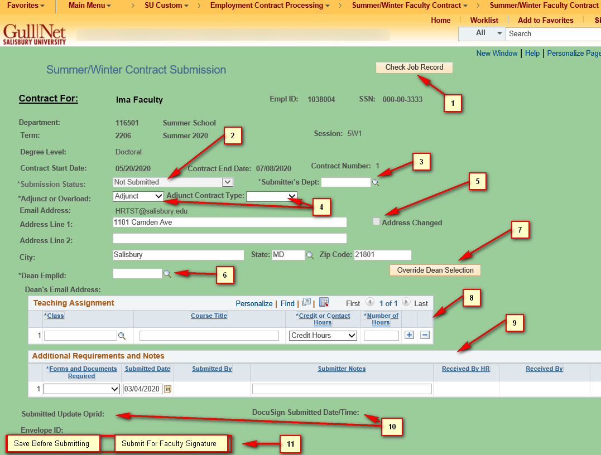

- The page shown above contains numbered field and controls (numbered for reference purposes for this document only as they do not appear on the page). They are:

  - The “Check Job Record” button allows you to see the job records of the employee. They are based on the Empl Record of the employee and include active as well as non-active jobs. This is for informational purposes only.
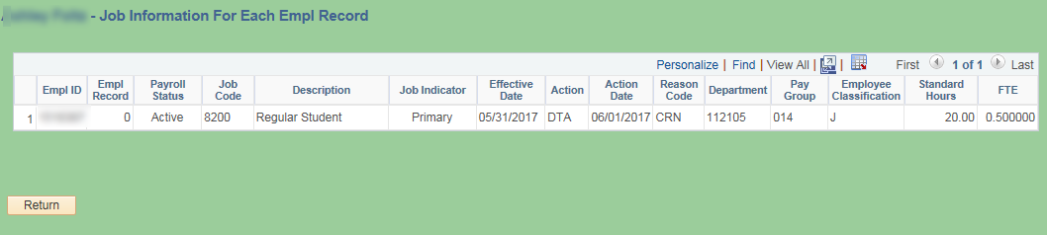

  - Submission Status: This is a read-only field and is set to “Not Submitted” until the contract has been submitted.
  - Submitters Department: This is the department code of the Admin submitting the contract. It is not included on the contract when sent unless it was used as the charged Department Code. It also serves to populate values in the Dean Emplid field.
  - Adjunct or Overload: This field is populated when you first add the record and are transferred to this page. Normally, you will not have to change this but you can if the categorization is incorrect. If the faculty is an adjunct, another drop/down box appears called Adjunct Contract Type. You must choose Adjunct I or Adjunct II.
  - Address Changed: This checkbox is not editable and only is checked if you change any address information. When the page is loaded the home address of the faculty is loaded. If you modify any of the fields (Address Line 1 or 2, City, State, or Postal Code) this box will be checked when the address is changed. This will alert the HR Office to send the faculty the proper paperwork needed to formally change the home address.
  - Dean Emplid: The Dean Emplid will normally only have one or two values selectable from the search magnifying glass. These values are tied to the Department of the Admin submitting the contract. When selected, the email addresses below the emplid will automatically be populated. If there are no values when you click the magnifying glass check that the Submitters Dept is filled.
  - Override Dean Selection button: When clicked will allow you to use any faculty staff emplid when clicking on the Dean Emplid magnifying glass.
  - Teaching Assignment: At least one course must be entered in order for the record to be saved. The courses available via the lookup are based on courses that are currently in the schedule in GullNet for the selected term/session.
  - Additional Requirements and Notes: These are additional documents required or notes that you can enter that the Faculty will have to provide based on their job information (contact HR for further clarification). Please leave as “None” if no additional documents are required or if you have no notes to make.
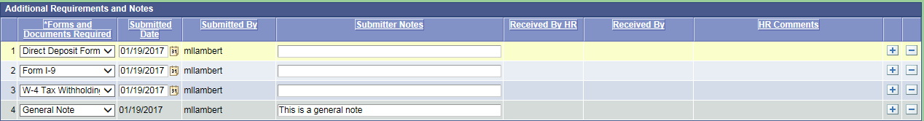

  - Submitted Oprid and Submitted Date: These read only fields are populated when you submit the contract.
  - The “Save Before Submitting” button can be pressed to save all your data without submitting the contract process through DocuSign. The “Submit For Faculty Signature” button actually starts the DocuSign workflow process.

HR Instructions

When the contract “Submission Status:” is “HR Data Input Needed” it is ready for HR submission. The section below is only visible to HR staff.

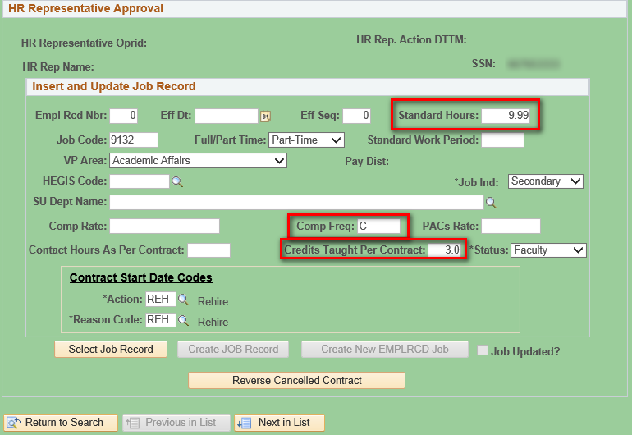

- The page shown above contains fields which will be used to populate the Job record of the faculty when the HR submitter clicks on the “Create JOB Record” or “Create New EMPLRCD Job” button.
- Fields that are in the red squares will be populated from data entered (or calculated) by the contract administrator who started the contract process. HR may still edit these though if they wish. All other fields are defaulted or as in the case of the “Action” and “Reason” code fields are determined by the program or “Select Job Record” button. These are all editable by the HR rep.
- When the HR submitter clicks on the “Select Job Record” they will see a list of all the highest job rows for each EMPL_RCD for that faculty. Clicking the select button at the end of the row will populate the data for all the fields that are not in red squares if the data is available. These fields are also editable if you wish to use your own values.
- The “Contract Start Date Codes” box and fields are critical since they determine how the job record is created in HR. Please make sure these are correct before you submit via the “Create JOB Record” button or the “Create New EMPLRCD Job” button.
- Once the the HR submitter clicks on the “Create JOB Record” button ” or “Create New EMPLRCD Job” button the “Job Updated?” check box will become checked and the submission status will be updated to “Commitment Acct Input Needed”, but if there is an error please contact IT.
- NOTE: Please use the “Create New EMPLRCD Job” button for a faculty for whom you wish to create a new EMPL record.

