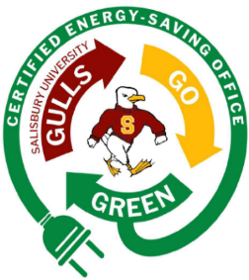Gulls Go Green Energy-Saving Office Program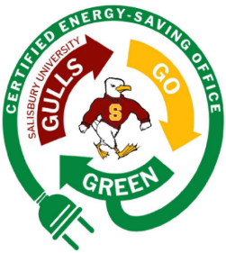
Thanks for your interest in the voluntary Gulls Go Green Energy-Saving Office program. The goal of this program is to actively involve the greater campus community in our sustainability initiatives and to ensure your individual actions do not go unnoticed. Offices across campus have already implemented several sustainable practices such as installing LED lights, battery recycling stations, and deskside recycling bins. This program is focused on lowering our energy usage and carbon emissions. Salisbury University has set an ambitious goal to be a net-zero campus by 2045, and simple actions such as unplugging your appliances and devices can help Salisbury University reach this goal.
The Office of Sustainability has taken the initiative of calculating the yearly average energy usage from a variety of common office electronics, appliances, and climate control items. On your scorecard, each kilowatt hour (kWh) an item uses per year is worth one point. Offices can be certified on the single occupant level or multiple occupant (shared office) level. Certifying at the shared office level has some extra benefits. We recognize that some shared offices on campus have SU owned shared printers and appliances. If your shared office has any SU owned shared printers and appliances, these items do not count towards your total score. However, all individuals’ electronics, appliances, and climate control items must be accounted for. If applying at the shared office level, all individuals in your office must be made aware of your application submittal and must be cc’ed on your submission email.

Certification Levels
Individual Office Space
Single Occupant Certified Energy-Saving Office: An individual must score 400 points or fewer.
Single Occupant Sammy’s Super Energy Saver: An individual must score 350 points or fewer.
Shared Office Space
Multiple Occupants Certified Energy-Saving Office: Individuals must average 300 points or fewer. (For example: an office with four workers must score 1,200 points or less)
Multiple Occupants Sammy’s Super Energy Saver: Individuals must average 250 points or fewer. (For example: an office with four workers must score 1,000 points or less)

All Certified Energy-Saving Offices will be promoted on Salisbury University's Sustainability website. They will also receive a Certified Energy-Saving Office sticker that can be proudly displayed on an office door or window.
Office Space Information:
Building:
Room Number:
Department:
Name of all Staff and Faculty:

Scorecard Directions: Please double-click on the scorecard to begin entering your office data in the Total Electronics, Appliances, and Climate Control columns. The scorecard will automatically calculate your final score.
*If you have items that are not listed, please add them to the "other" category, and the value will be calculated by the Sustainability Office.
Please submit your scorecard to Chris Homeister, Chief Sustainability Officer, at cshomeister@salisbury.edu. Upon review of your scorecard, you'll be contacted to schedule a walkthrough your office to verify all recorded electronics, appliances, and climate control items. When your walkthrough is complete, you’ll receive your Certified Energy-Saving Office sticker to display in your office.

